CURRICULAM VITAE

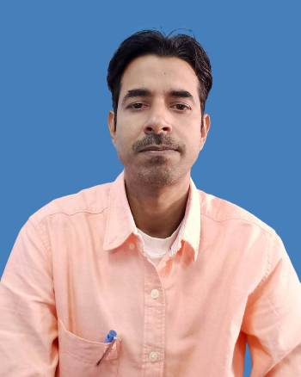

DR. santosh mukherjee

C/o- Gangadhar Mukherjee
Vill+ P.O- Kota, Raipara.
Near Raipara Durga Mandir
P.S- Dubrajpur, Birbhum
PIN- 731124
Mobile – 09126223615 / 7908169929
E-Mail – santoshvu1@gmail.com, drsmukherjeergu@gmail.com

ACADEMIC / PROFESSIONAL QUALIFICATION
BOARD/  UNIVERSITY | EXAMINATION | YEAR OF PASSING
NETAJI SUBHAS OPEN UNIVERSITY | M.COM | Pursuing
RAIGANJ UNIVERSITY | Ph. D in Economics | 2026
VIDYASAGAR UNIVERSITY | M.B.A  (MARKETING & HR) | 2009
BURDWAN UNIVERSITY | B.Com | 2006

COMPUTER SKILL
Name Of The Institute | Year Of Passing | Course Conducted By | Stream | Percentage of Marks /Grade
FUTURE POINT,  PURANDARPUR | 2008 | FUTURE POINT,  PURANDARUR  W.B Govt. Regd. | Diploma in Financial Accounting (DFA) | “A” Grade

Area of Teaching & Research Interest: Human Resource Management, Organisational Change & Development, Strategic Management, Performance Management, Organisational Behaviour & specialization areas of Marketing Management.
Research Experience: 1Year 10 months experience as a Project Associate in a ICSSR Major Research Project Under Lingaya’s University, Faridabad, from 1st October 2015 to 17th July 2017.
Academic & Administrative Experience: - More than 14 years experience in the academic field out of which 2 years as a Full Time Lecturer cum H.O.D (Dept. of BBA) in Raniganj Institute of Computer and Information Sciences (RICIS) affiliated to Burdwan University, from July 2010 to June, 2012 and 11months experience as a Teacher- in- Charge of RICIS from 1st July 2012 to 31st May 2013. 2Years 4 Months Experience as a Full Time Lecturer in GD Bagaria Institute of Management (Giridih) affiliated to Vinoba Bhave University, from 1stJune, 2013 to 30thSeptember 2015.
Presently working as an Assistant Professor (Contractual) at Raiganj University, Uttar Dinajpur from 18th July 2017.

Member of the Organizing Committee:
- Acted as a convener of the national level online seminar on ‘Entrepreneurship as a career’ organized by Department of Business Administration, Raiganj University in collaboration with ‘Entrepreneurship Development Institute of India’ on 14th June, 2021.
- Acted as a convener of the One day Webinar on ‘Investors Awareness Programme’ organized by Department of Business Administration, Raiganj University in collaboration with BSE Ltd. on 15th June, 2021.
Seminar, Workshop & Journal Paper:
- Participated in an online Curriculum Workshop on BBA in Rural Management conducted by Mahatma Gandhi National Council of Rural Education, Hyderabad, Govt. of India on 9th December 2020.
- Participated in a Three Days International Workshop on Qualitative and Quantitative Data Analysis for Social Scientists held from 26th November to 28th November, 2022 jointly organised by Department of Economics, Geography and Sociology of Raiganj University.
- Presented a paper in one day International Seminar on Asian Approaches of Socio Economic development for Human Progress held on 2nd March, 2023 organized by eastern Institute for Integrated Learning in Management.
- Presented a paper in one day National seminar on Celebrating Seventy Five Years of Indian Independence held on 28/07/2023 organized by The Institute of Social and Cultural Studies, The Ministry of Culture, Govt. of India and in collaboration with Raiganj University, Uttar Dinajpur, W.B.
- Attended a Five Days Online Faculty Development Programme on Integrating Sustainability, effective Communication and Addressing New Age Challenges in Education, held from 19/02/2024 to 24/02/2024, organized by Suresh Gyan Vihar University.
- Published a paper on “A Critical evaluation of Multi-source Performance Appraisal Model for the faculty members followed by the Higher Academic Institutions in West Bengal”, LOOK EAST Vol. 8, No. 1, December 2022, pp. 100-114.
- Published a paper on “Performance Appraisal of Private University Teachers in West Bengal- A Study”, IOSR Journal of Humanities And Social Science (IOSR-JHSS) Volume 30, Issue 3, Series 7 (March, 2025) 74-81 e-ISSN: 2279-0837, p-ISSN: 2279-0845.
- Published a paper along with Dr. Supriyan Sen & Umesh Sarkar on Optimizing Cluster Head Selection for Reliable and Efficient WSNs under Uncertainty, www.kadsa.org, eISSN: 3079-6318, Knowledge and Decision Systems with Applications, Volume 1, 2025, 177-190.
- Acted as a Resource Person in the Value Added Course on Behavioral Approach to Human Resource Management from 10/06/2024 to 21/06/2024 organized by Department of Commerce, Banwarilal Bhalotia College, Asansol in collaboration with Maharaja Manindra Chandra College, Kolkata under the Aegis of IQAC, Banwarilal Bhalotia College, Asansol

PERSONAL PROFILE
Father Name - Gangadhar Mukherjee

Date of Birth - 07th August,1983

Sex - Male.

Marital Status - Married.

Nationality - Indian.

Languages Known - English, Bengali, and Hindi.

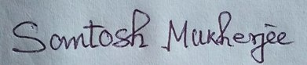
Date: 10/06/2026 ------------------------------
Place: Raiganj Signature
(Santosh Mukherjee)

